Notes on Goldberg Cut-Off – Janet Tooze

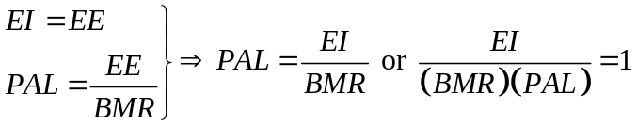

PAL and EI have a skewed distribution, so assume lognormal

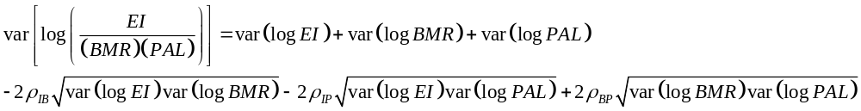
The paper states that the coefficient of variation (CV) = log SD.

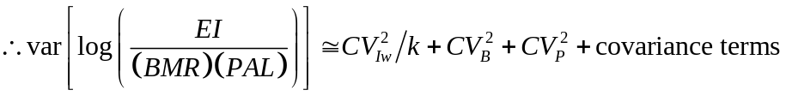,
where k is the number of repeated measures, and 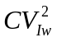 denotes within-subject variation.

(Goldberg et al. note that for FFQ, 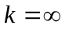 and 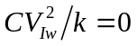, because the instrument is used to measure “usual” intake)

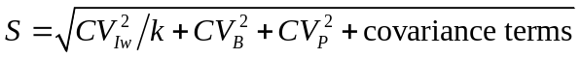

To compute SD score to evaluate the probability of a result being within range:

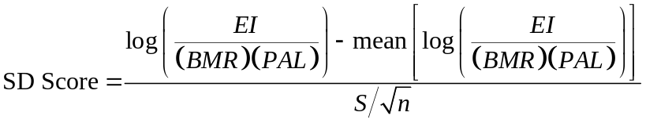,
where 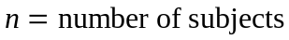.

Under energy balance 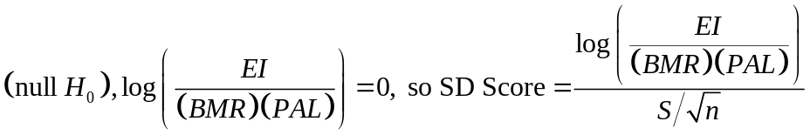.

Covariance
If EI and BMR are measured, 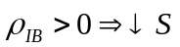
If BMR is estimated,
For PAL, a single population value is assumed so 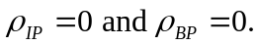

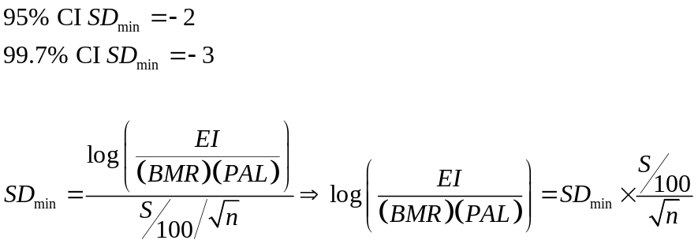

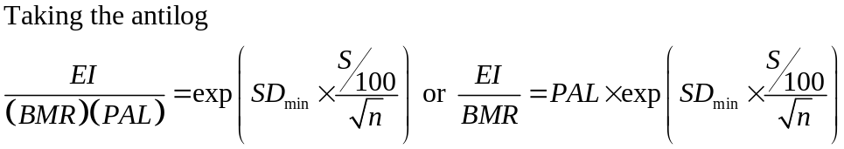

Use
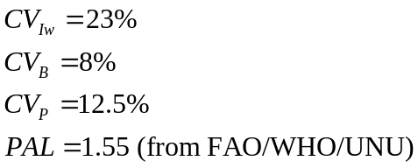

Example
For 95%, n=10, measured over 7 days:

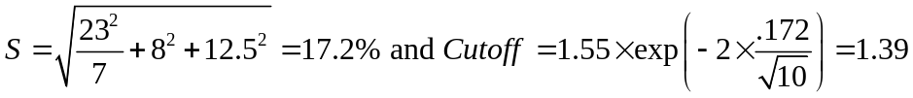

So, the mean EI/BMR must be greater than 1.39 to be reasonable. (See Goldberg et al. p.576 for cutoffs)

From Black, 2000 – Update

Update of Values

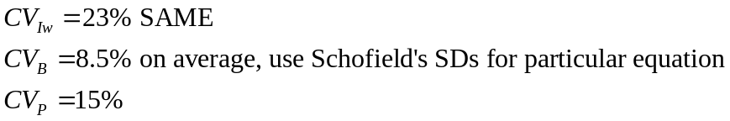
- For women with BMI>35, Schofield may overestimate BMR
- Sensitivity may improve if individuals are assigned to low, medium, and high levels of activity and 3 different PALs are assigned
- See p.1127 of Black for updated tables

